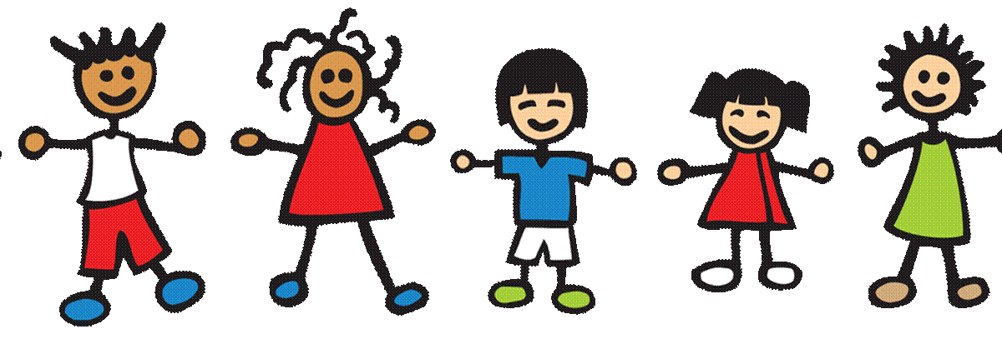
Dauphin County MH/A/DP
TINY BIT november 2025

Teaching Toddlers to Handle Conflicts

Caregivers have their own style of parenting when teaching their children coping skills. During infancy, some parents may opt to constantly hold their crying babies, while others, at times, may choose to let them cry it out. Some may remove the pacifier earlier than others to force their children to use environmental input to soothe. Similarly, some caregivers may be very strict regarding emotional outbursts, while others may allow their children to openly express themselves.
Regardless of the method of choice, caregivers know the day will come when their children face conflicts that they will have to handle on their own. How many times has a story circulated in the news about a young one meeting a tragic end over some trivial matter? Could it have been that the aggressor was never taught coping skills to handle conflicts? Most parents try to address their baby’s whims. Gradually, however, children learn from their caregivers, how far to press an issue, and that sometimes, no is the final answer.
The need to continue to teach our children how to resolve conflicts is vital for their future wellbeing. Gone are the days when friends would become aggressive with each other, then would make up and forget about it. Today, children hold grudges, and even more alarming, they have access to weapons. Minor spats or altercations can lead to tragedy. Some hold on to past conflicts and decide to confront the person if ever they cross paths no matter how many years may have passed.
What can be done? The only behavior our kids can control is their own, so teaching them how to avoid conflicts or how to lessen the severity of a situation with a peer may save their lives. Arguing over toys as tots may someday change to arguing over grades, money, girls or boys. Thankfully, nothing remains the same for too long. Thus, patience (Some people take much longer to mature or have not been taught coping skills), humility (It’s ok to let someone else have the final say), and empathy (An aggressive person may be acting out due to something unknown to anyone else) are great virtues to instill in children. Teaching toddlers to handle conflicts, by guiding them to find ways to promote peace when dealing with others, is a great way to help them learn to resolve minor issues, before the consequences for their involvement in those issues (as they age), become life altering. Peaceful kids can spread peace to others!
https://mentalhealthcenterkids.com/blogs/articles/conflict-resolution-for-kids
Teaching Kids How to Deal With Conflict - Child Mind Institute
Tiny BITs (Better informed Together)
For Families With Young Children

